EASTER RISING

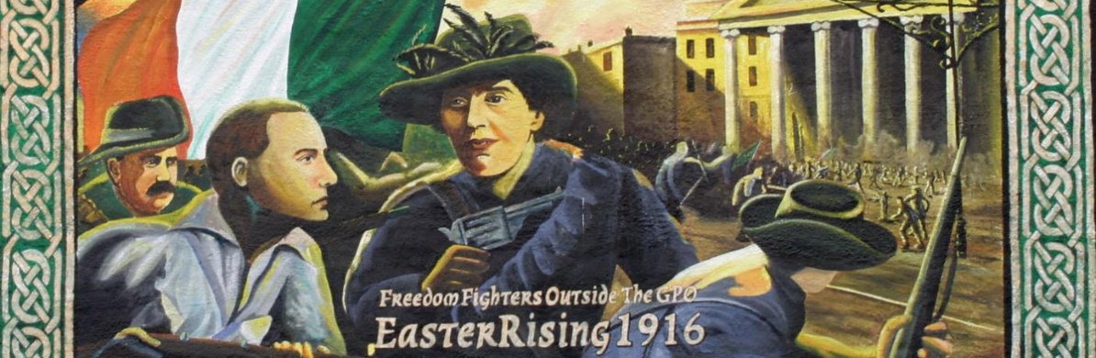
On Easter Monday, April 24, 1916, a group of Irish nationalists proclaimed the establishment of the Irish Republic and, along with some 1,600 followers, staged a rebellion against the British government in Ireland. The rebels seized prominent buildings in Dublin and clashed with British troops. Within a week, the insurrection had been suppressed and more than 2,000 people were dead or injured. The leaders of the rebellion soon were executed. Initially, there was little support from the Irish people for the Easter Rising; however, public opinion later shifted and the executed leaders were hailed as martyrs. In 1921, a treaty was signed that in 1922 established the Irish Free State, which eventually became the modern-day Republic of Ireland.

1916 EASTER RISING: BACKGROUND
With the Act of Union in 1800, Ireland (which had been under some form of English control since the 12th century) merged with Great Britain to form the United Kingdom of Great Britain and Ireland. As a result, Ireland lost its parliament in Dublin and was governed by a united parliament from Westminster in London. During the 19th century, groups of Irish nationalists opposed this arrangement in varying degrees.
Some moderate nationalists advocated for home rule, under which Ireland would remain part of the United Kingdom but also have some form of self-government. Several home rule bills were defeated in Parliament in the late 1800s before one finally passed in 1914. However, implementation of home rule was suspended due to the outbreak of World War I (1914-18).
Meanwhile, members of a secret revolutionary organization called the Irish Republican Brotherhood (IRB), who believed home rule wouldn’t go far enough and instead sought complete independence for Ireland, began planning what would become the Easter Rising. They hoped their rebellion would be aided by military support from Germany, which was fighting the British in World War I. Roger Casement (1864-1916), an Irish nationalist, arranged for a shipment of German arms and ammunition for the rebels; however, shortly before the insurrection began, the British detected the ship and it was scuttled by its captain. Casement was charged with treason and executed in August 1916

EASTER RISING: APRIL 1916
The Easter Rising was intended to take place across Ireland; however, various circumstances resulted in it being carried out primarily in Dublin. On April 24, 1916, the rebel leaders and their followers (whose numbers reached some 1,600 people over the course of the insurrection, and many of whom were members of a nationalist organization called the Irish Volunteers, or a small radical militia group, the Irish Citizen Army), seized the city’s general post office and other strategic locations. Early that afternoon, from the steps of the post office, Patrick Pearse (1879-1916), one of the uprising’s leaders, read a proclamation declaring Ireland an independent republic and stating that a provisional government (comprised of IRB members) had been appointed.
Despite the rebels’ hopes, the public did not rise to support them. The British government soon declared martial law in Ireland, and in less than a week the rebels were crushed by the government forces sent against them. Some 450 people were killed and more than 2,000 others, many of them civilians, were wounded in the violence, which also destroyed much of the Dublin city center. Initially, many Irish people resented the rebels for the destruction and death caused by the uprising.

1916 EASTER RISING: AFTERMATH
In May, 15 leaders of the uprising were executed by firing squad. More than 3,000 people suspected of supporting the uprising, directly or indirectly, were arrested, and some 1,800 were sent to England and imprisoned there without trial. The rushed executions, mass arrests and martial law (which remained in effect through the fall of 1916), fueled public resentment toward the British and were among the factors that helped build support for the rebels and the movement for Irish independence.
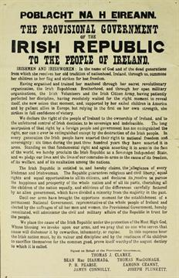
In the 1918 general election to the parliament of the United Kingdom, the Sinn Fein political party (whose goal was to establish a republic) won a majority of the Irish seats. The Sinn Fein members then refused to sit in the UK Parliament, and in January 1919 met in Dublin to convene an Irish Parliament (known as the Dail Eireann) and declare Ireland’s independence. The Irish Republican Army then launched a guerilla war against the British government and its forces in Ireland. Following a July 1921 cease-fire, the two sides signed a treaty in December that called for the establishment of the Irish Free State, a self-governing nation of the British Commonwealth, the following year. Ireland’s six northern counties opted out of the Free State and remained with the United Kingdom. The fully independent Republic of Ireland (consisting of the 26 counties in the southern and western part of the island) was formally proclaimed on Easter Monday, April 18, 1949. (history.com)

